**Test Configurations**

Suppose you want to test login function for different username

Or credit card payment function for different credit card types (AMEX, VISA, MASTERCARD)

So, in this kind of situations, instead of creating a new test and rewriting the test steps again

You will use Test Configuration to do the same test for different parameters you want to use

After creating the parameters, you go to Test Configuration tab.

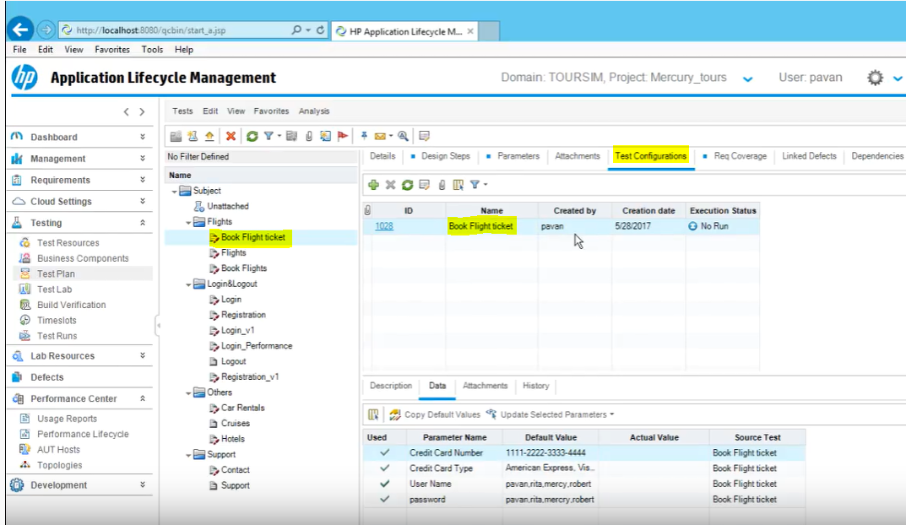

When you open the Test Configuration, there will be default configuration which is same as your test name. You can double click and change the name of that as your first configuration name.

In this example, we are creating test configurations for different credit card type

So, lets rename the default as AMEX, then we can create two more configurations for VISA and MASTERCARD

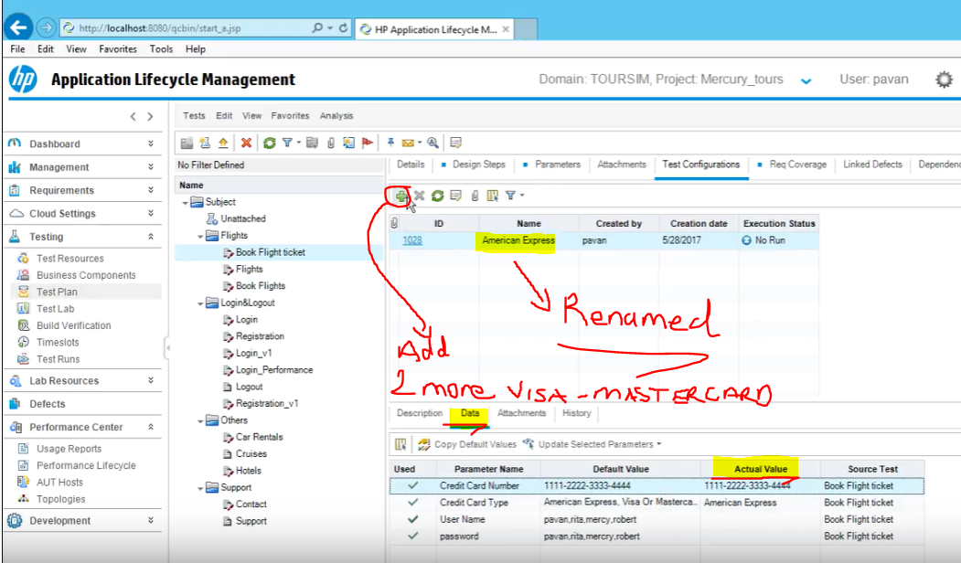

While adding new configurations

Click on Data Tab and select the actual values for that specific configurations.

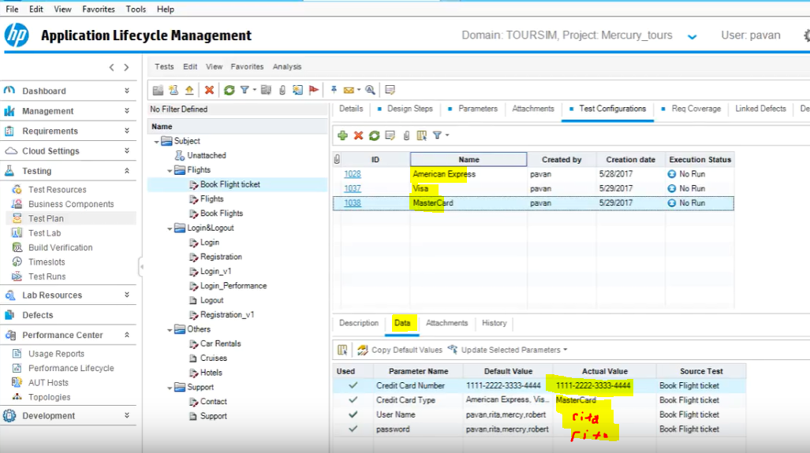

You can create more configurations and select the actual values from the parameters